|  |  |
| --- | --- |
|  | Instructor  Muhammad  Affan |
| Fundamentals of Programming |
|  |  |

[](https://www.myperfectresume.com/membership/RegisterGuestUser.aspx?wizard=true&productid=17&utm_source=hloom-com&utm_medium=referral&utm_campaign=word-template)

LAB TASK

**Muhammad Dawood Saeed**

ME-15-C

465231

X

Xx

**LAB TASK 4**

**Q1**

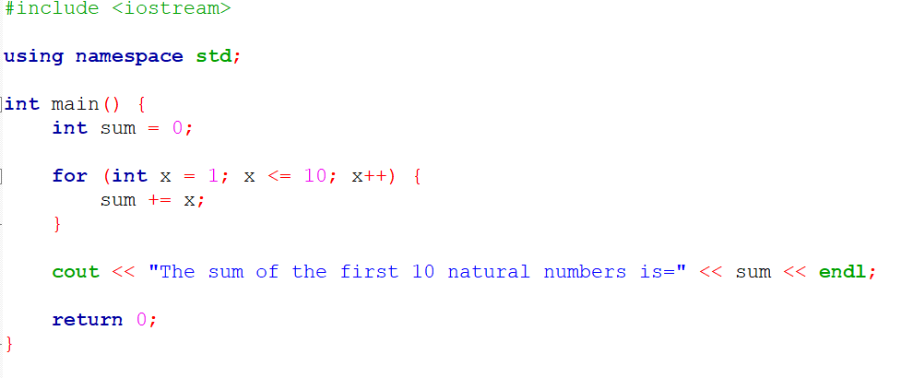

**ANS 1**

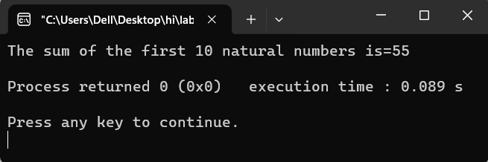

**Q2**

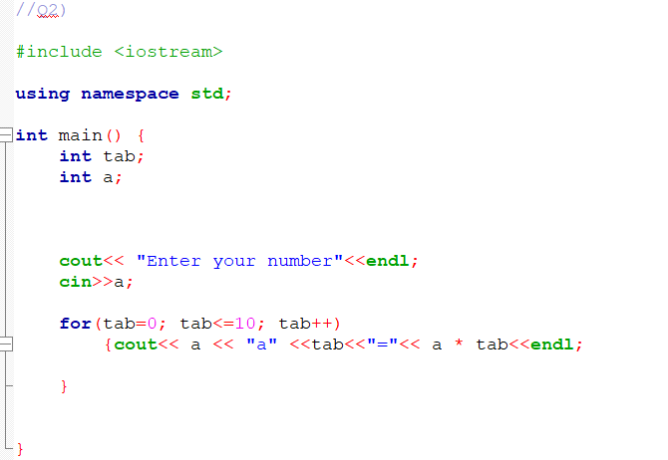

**ANS 2**

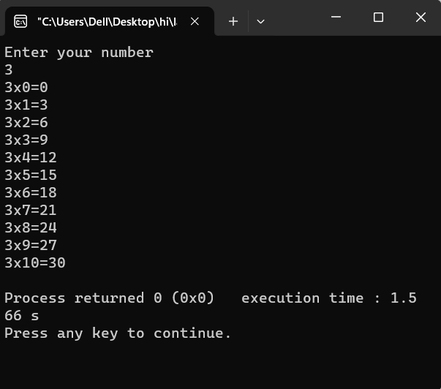

**Q3**

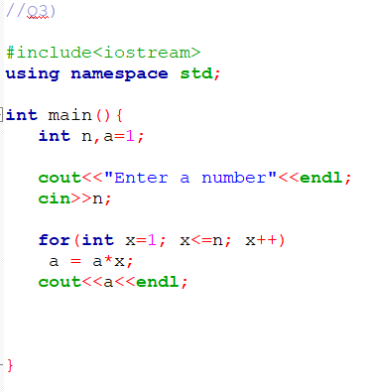

**ANS 3**

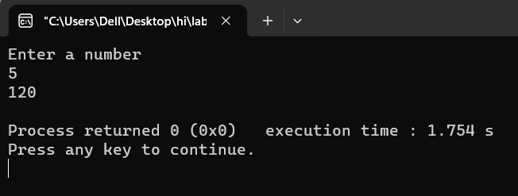

**Q4**

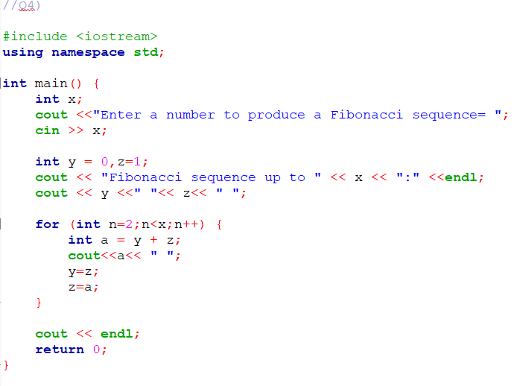

**ANS 4**

